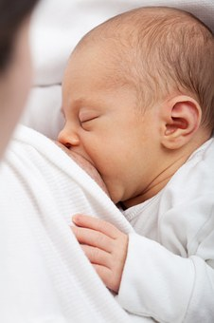

Breastfeeding & Lactation Preparation Classes

Breastfeeding Preparation classes will be resuming from 17/2/21. These will be available in limited numbers face-face and open via Zoom. Classes will be run 11am-12pm on Wednesdays and Fridays.

Please call 5454 7288 to book.

An online breastfeeding information package is available on the Bendigo Health website. This includes information about benefits of breastfeeding, normal newborn behaviour and breastfeeding handy hints.

**The online package can be accessed here:**<https://www.bendigohealth.org.au/PregnancyCare/>